Build a Logistic Regression Model for Customer Churn

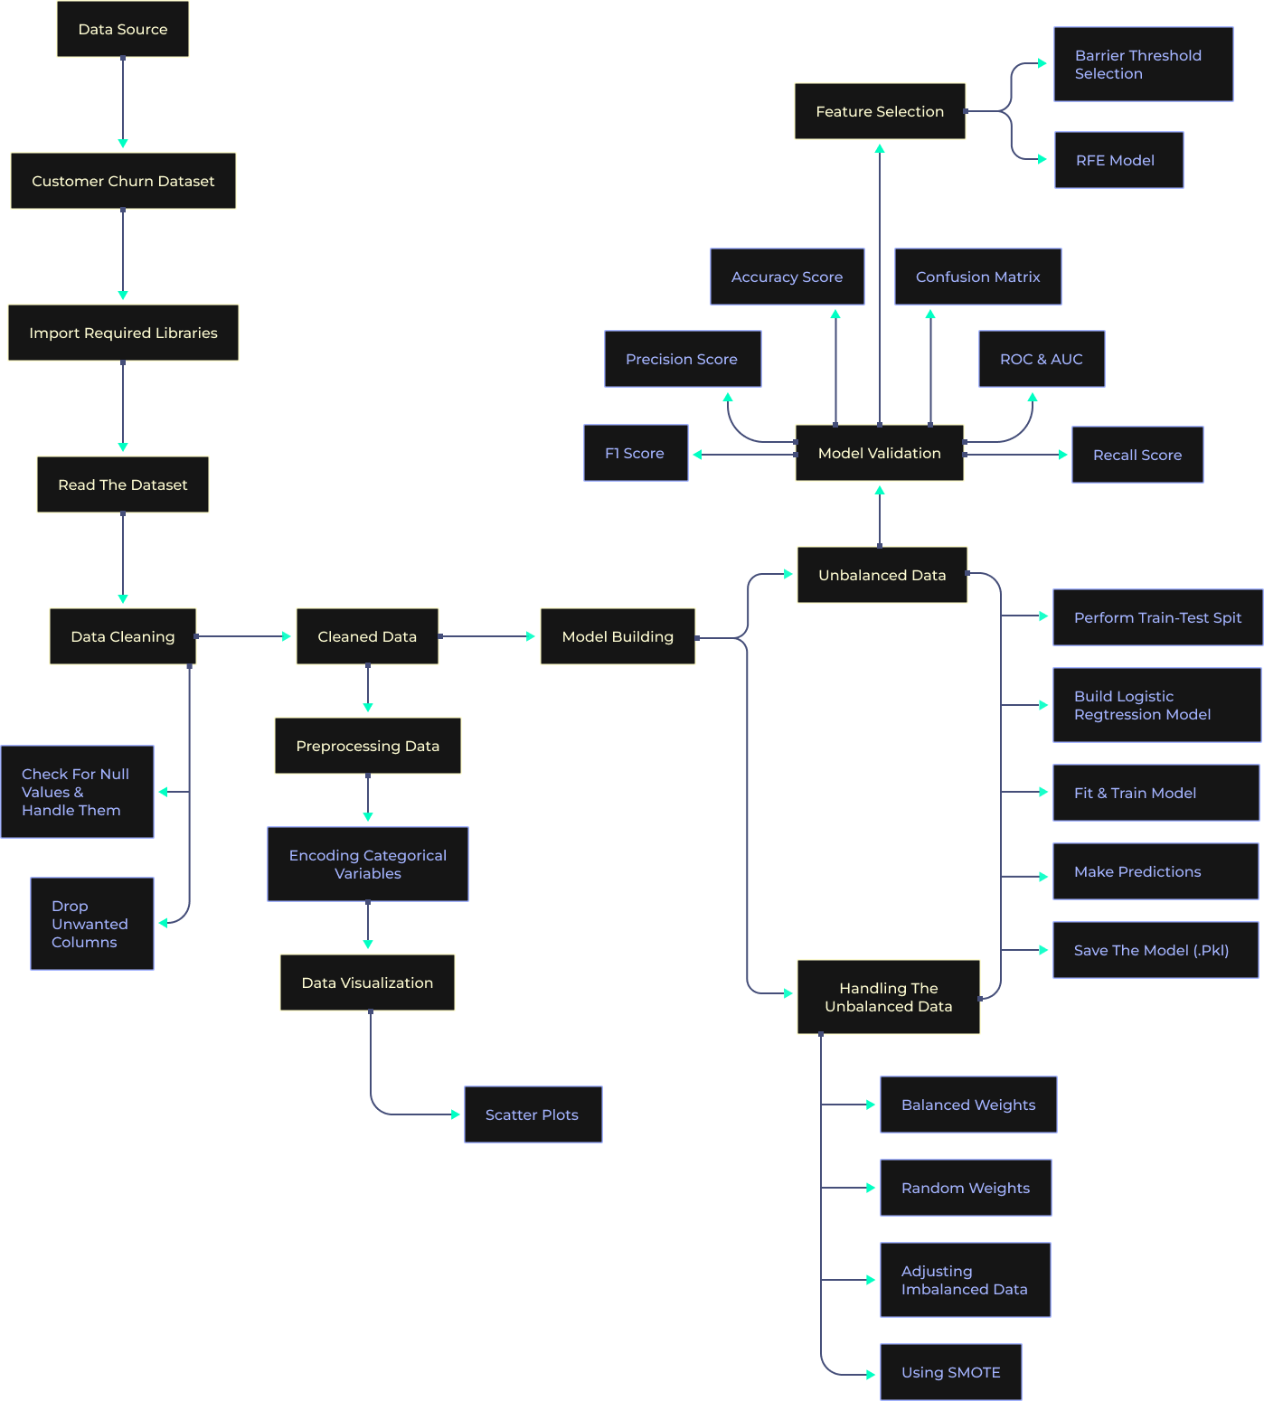

Business Objective
Predicting a qualitative response for observation can be referred to as classifying that observation since it involves assigning the observation to a category or class. Classification forms the basis for Logistic Regression. Logistic Regression is a supervised algorithm used to predict a dependent variable that is categorical or discrete. Logistic regression models the data using the sigmoid function.
Churned Customers are those who have decided to end their relationship with their existing company. In our case study, we will be working on a churn dataset.
XYZ is a service-providing company that provides customers with a one-year subscription plan for their product. The company wants to know if the customers will renew the subscription for the coming year or not.
Data Description
The dataset consists of approximately 2000 rows and 16 columns.
Features:
1. Year
2. Customer_id - unique id
3. Phone_no - customer phone no
4. Gender -Male/Female
5. Age
6. No of days subscribed - the number of days since the subscription
7. Multi-screen - does the customer have a single/ multiple screen subscription
8. Mail subscription - customer receive mails or not
9. Weekly mins watched - number of minutes watched weekly
10. Minimum daily mins - minimum minutes watched
11. Maximum daily mins - maximum minutes watched
12. Weekly nights max mins - number of minutes watched at night time
13. Videos watched - total number of videos watched
14. Maximum_days_inactive - days since inactive
15. Customer support calls - number of customer support calls
16. Churn -
- 1- Yes
- 0 - No
Aim
Build a Logistic Regression model to determine whether a customer will churn.
Tech Stack
Language: Python
Libraries:
- NumPy
- Pandas
- Matplotlib
- Seaborn
- Scikit-Learn
- Pickle
- Imbalanced-Learn
- StatsModels
Approach
1. Importing the required libraries and reading the dataset.
2. Inspecting and cleaning up the data
3. Perform data encoding on categorical variables
4. Exploratory Data Analysis (EDA)
- Data Visualization
5. Feature Engineering
- Dropping of unwanted columns
6. Model Building
- Using the stats model library
7. Model Building
- Performing train test split
- Logistic Regression Model
8. Model Validation (predictions)
- Accuracy score
- Confusion matrix
- ROC and AUC
- Recall score
- Precision score
- F1-score
9. Handling the unbalanced data
- With balanced weights
- Random weights
- Adjusting imbalanced data
- Using SMOTE
10. Feature Selection
- Barrier threshold selection
- RFE method
11. Save the model in the form of a pickle file
Project Takeaways
- Classification fundamentals
- Logistic Regression concepts
- Model evaluation metrics
- EDA and visualization
- Handling imbalanced datasets
- Feature selection techniques
- Model serialization using Pickle

